Access to AO Arena
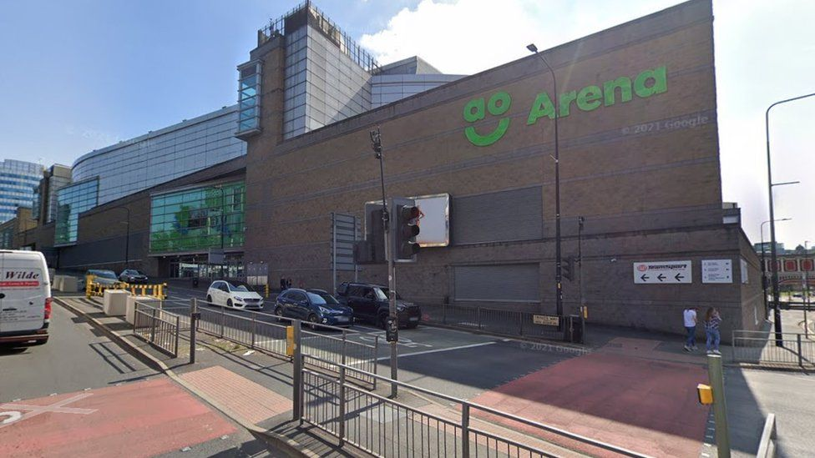

Booking Tickets and Accessible Seating

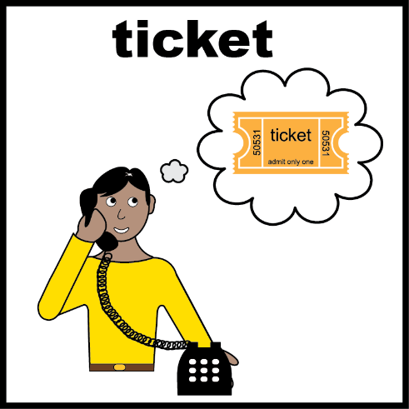
If you need accessible seating
or a companion ticket,
please call our ticketing partner AXS: 0161 987 5297.

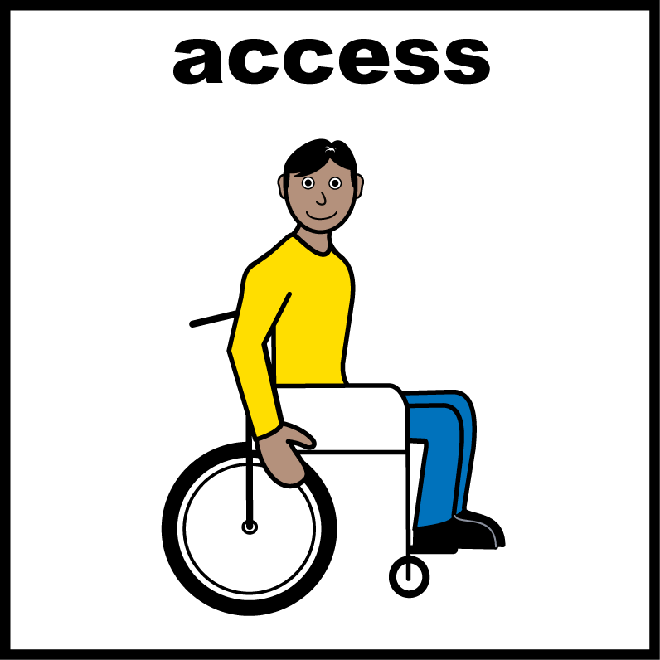
There are some wheelchair spaces. Call as early as you can to book these.

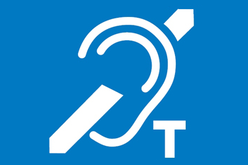
To book the induction loop please call: 0161 950 5229.

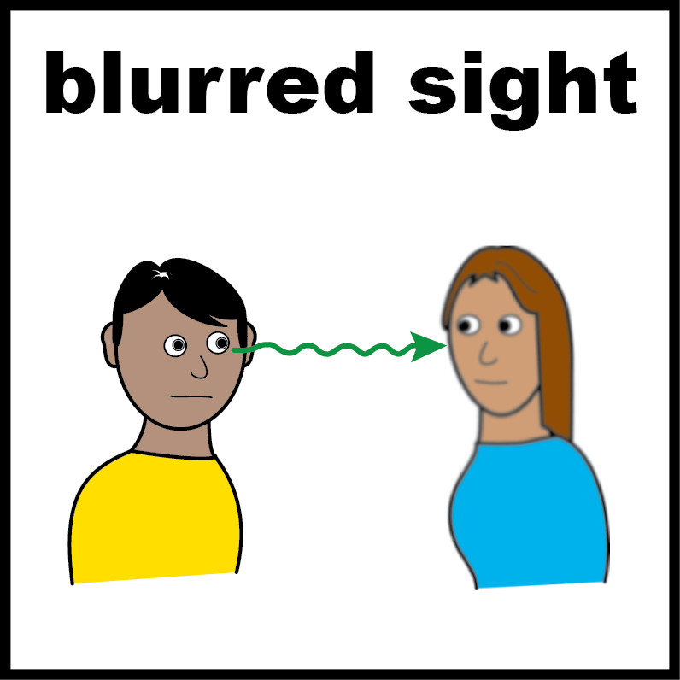
If you are blind or visually impaired you might be able to have a seat closer to the stage.
Please call our ticketing partner AXS: 0161 987 5297.

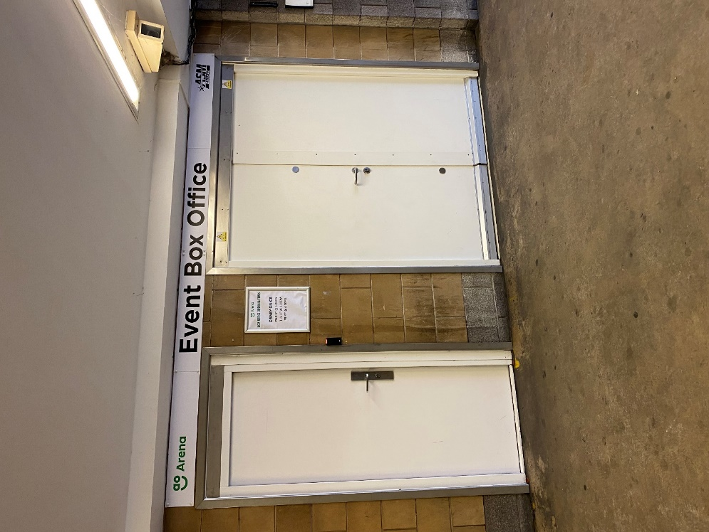
How can I access the Box Office?

The Box Office is located in the tunnel next to Trinity Way

The box office is only open on show days. Please check with us for the opening hours.

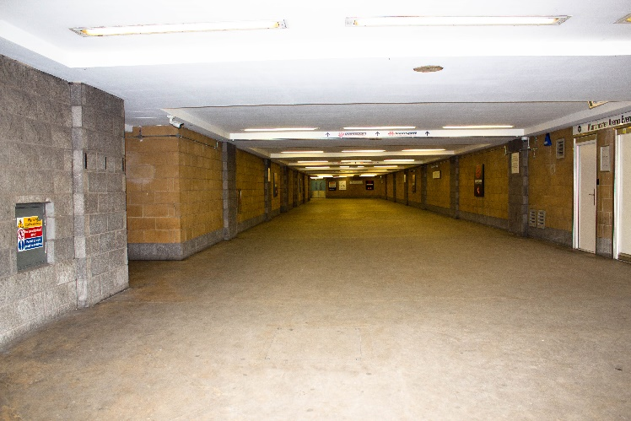
It can be visited from Trinity Way or the Car Park.

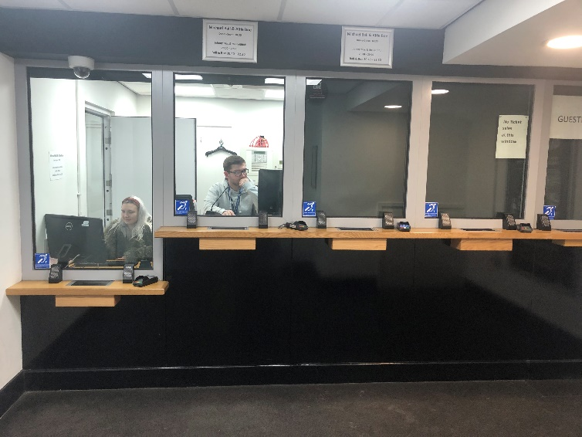
The Box office has:

A low level counter


Information in large type is available on request.

An induction loop.

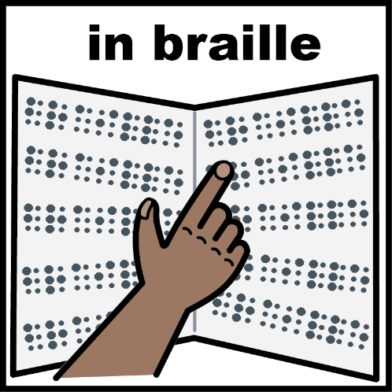
Information in Braille is available on request.

Getting to the Venue

Parking
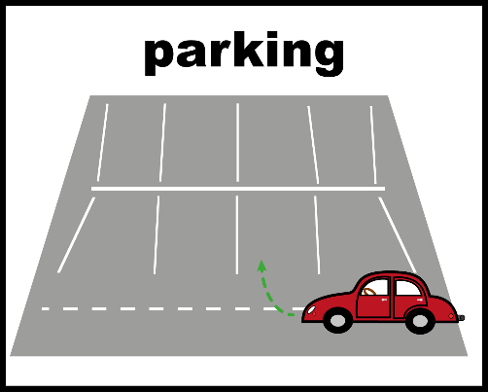
The nearest car park is at
CitiPark, AO Arena, M3 1AR

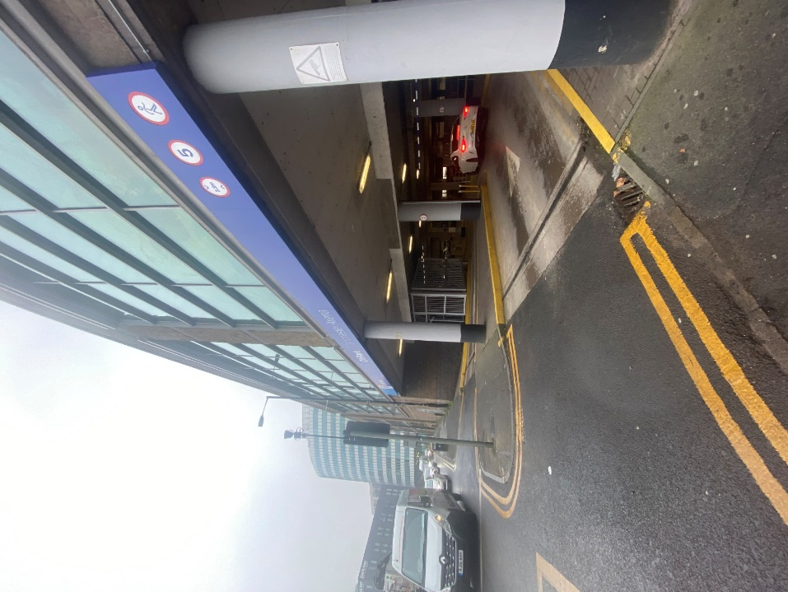

The car park entrance is on
Trinity Way/New Bridge Street.

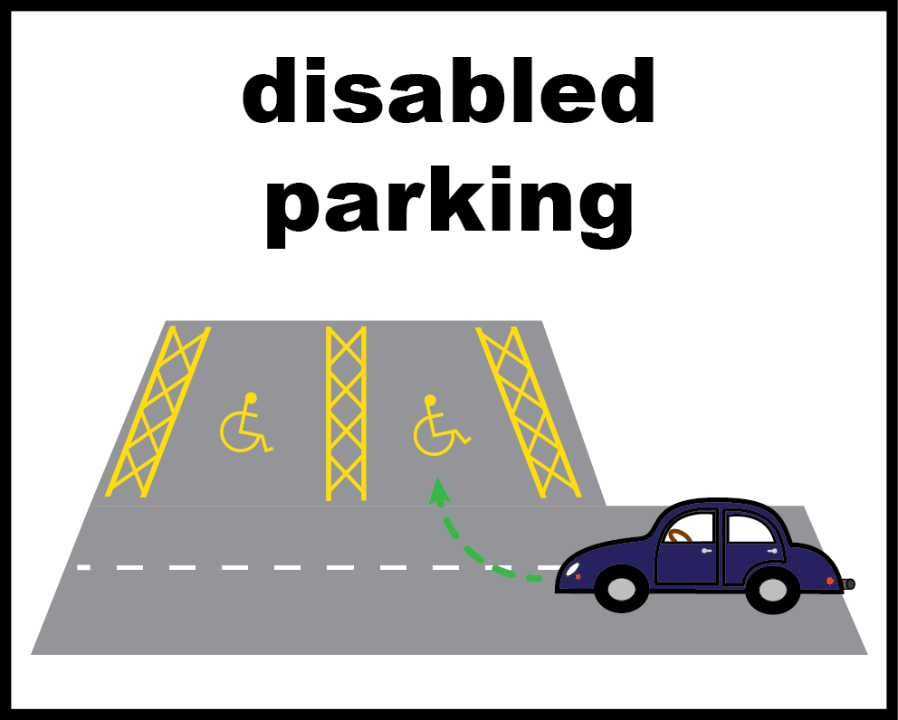
There are disabled parking spaces on all levels of the car park.

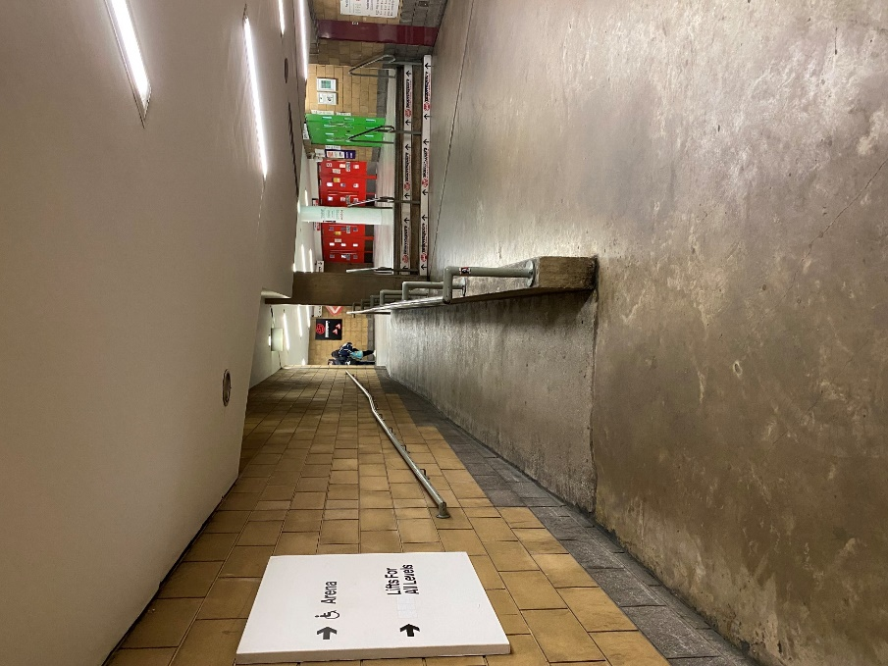

There is a ramp to the arena entrance.

Taxi
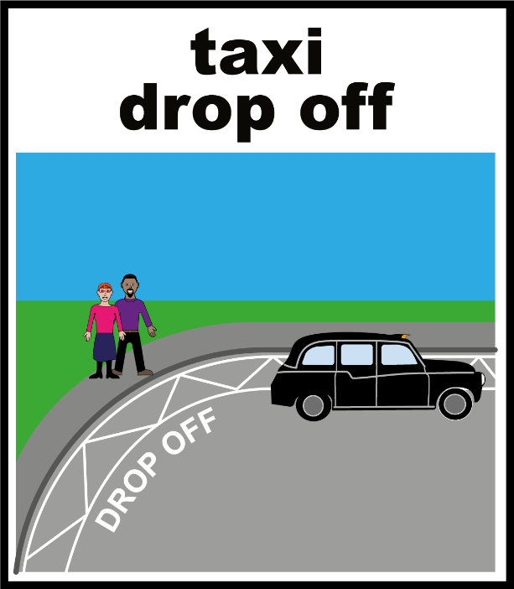
The taxi rank is located outside Manchester Victoria train station.

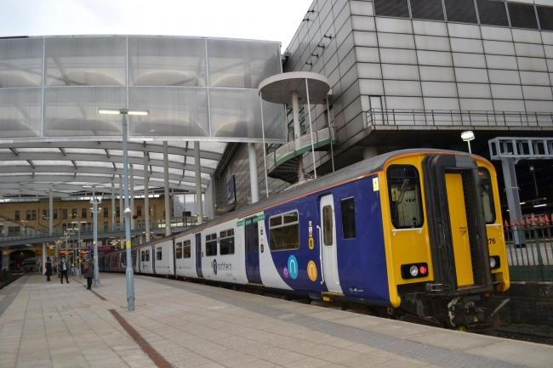
Train
The nearest train station is Manchester Victoria.

Tram
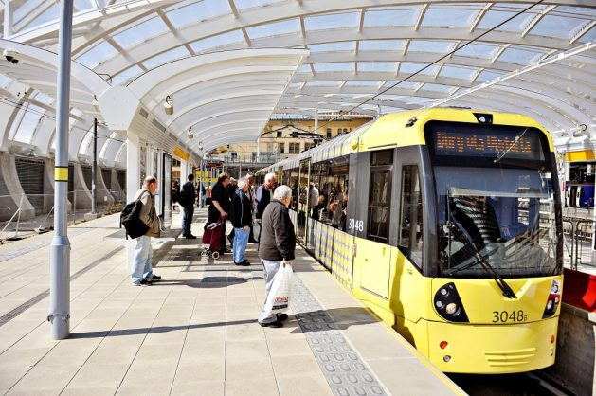
The nearest tram station is Victoria inside Manchester Victoria train station.

Bus
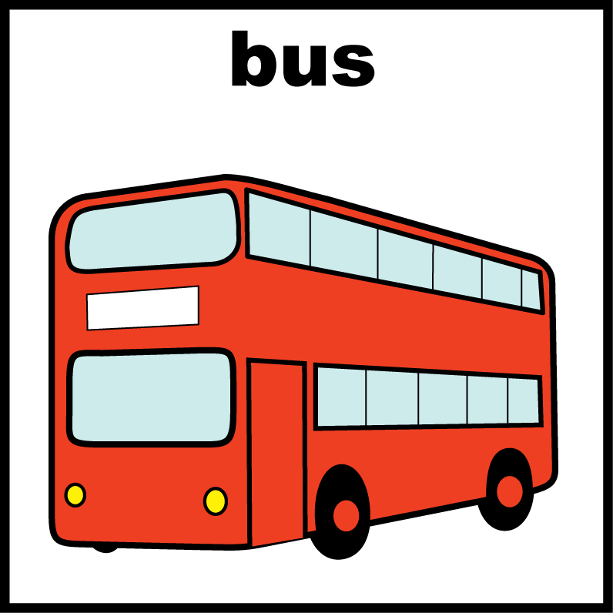
The nearest bus stops are outside Manchester Victoria train station.

Accessible Entrances

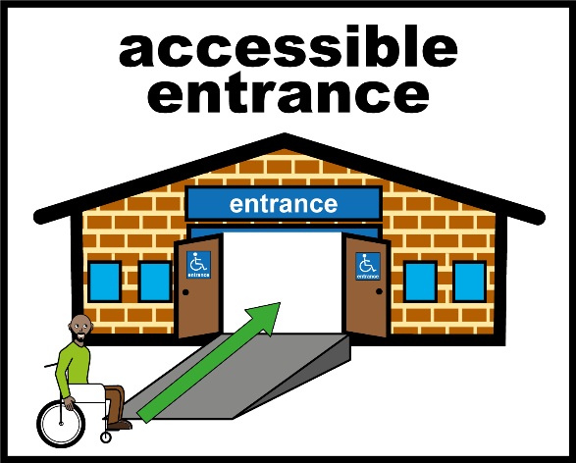
All of our entrances are accessible.

You can get into the AO Arena via:

Manchester Victoria Train Station

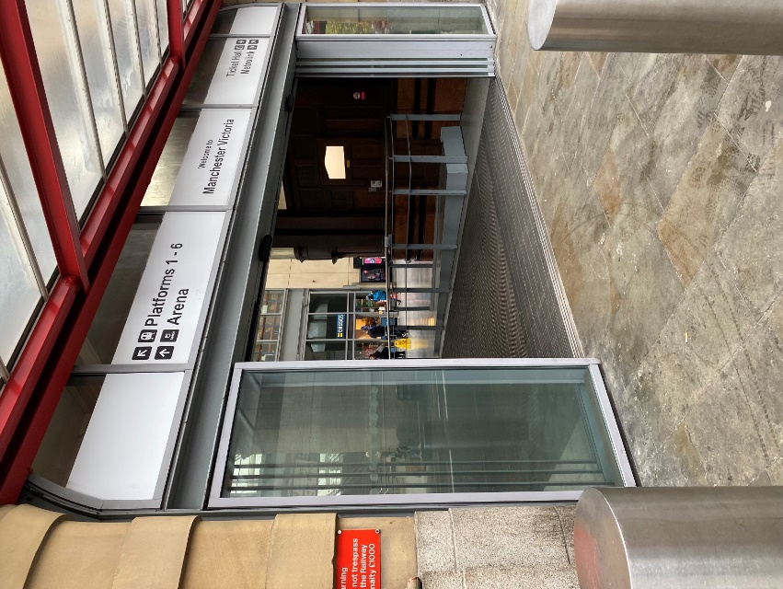
There is an entrance inside Manchester Victoria Train Station.

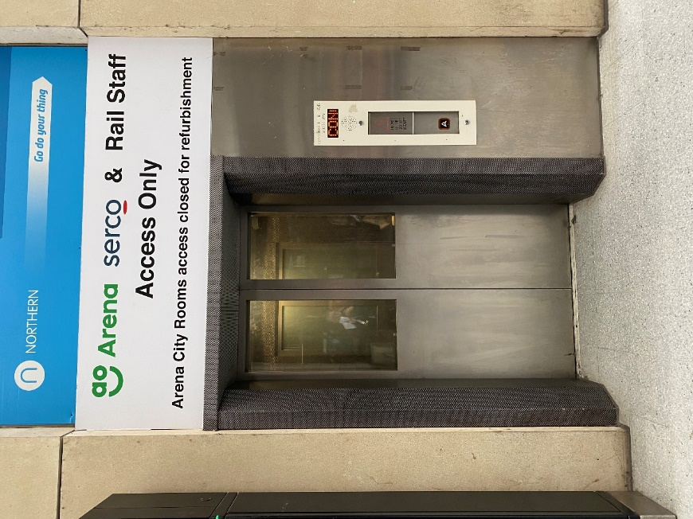
From here there is a lift to take you to the entrance.

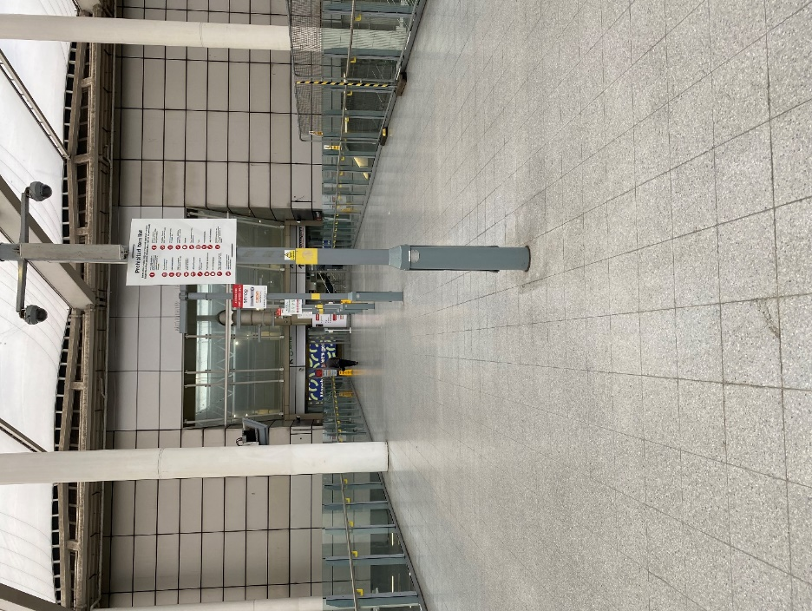
The entrance is across a bridge.

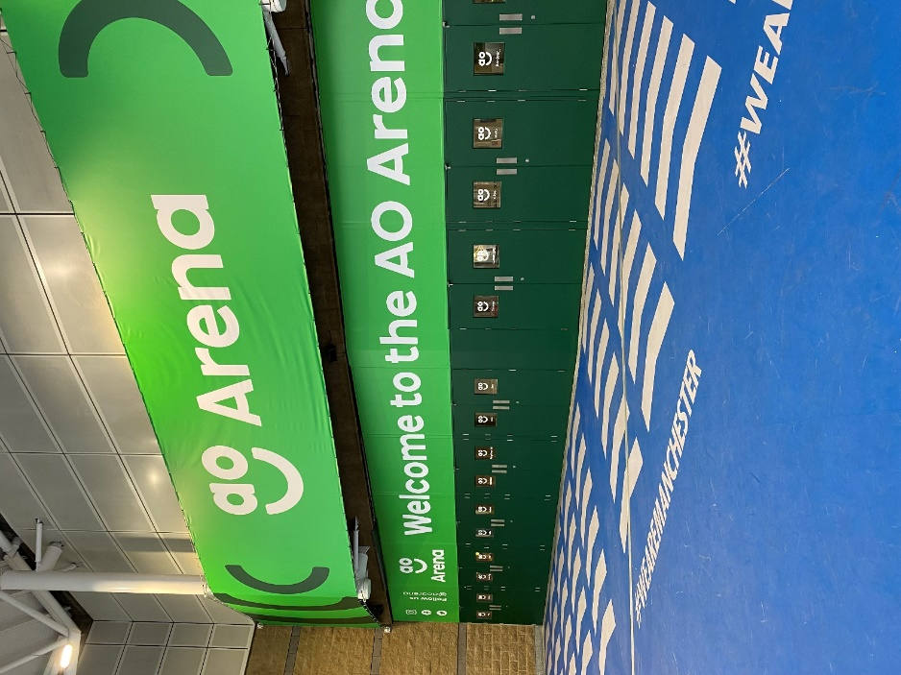

The City Rooms entrance is level access.

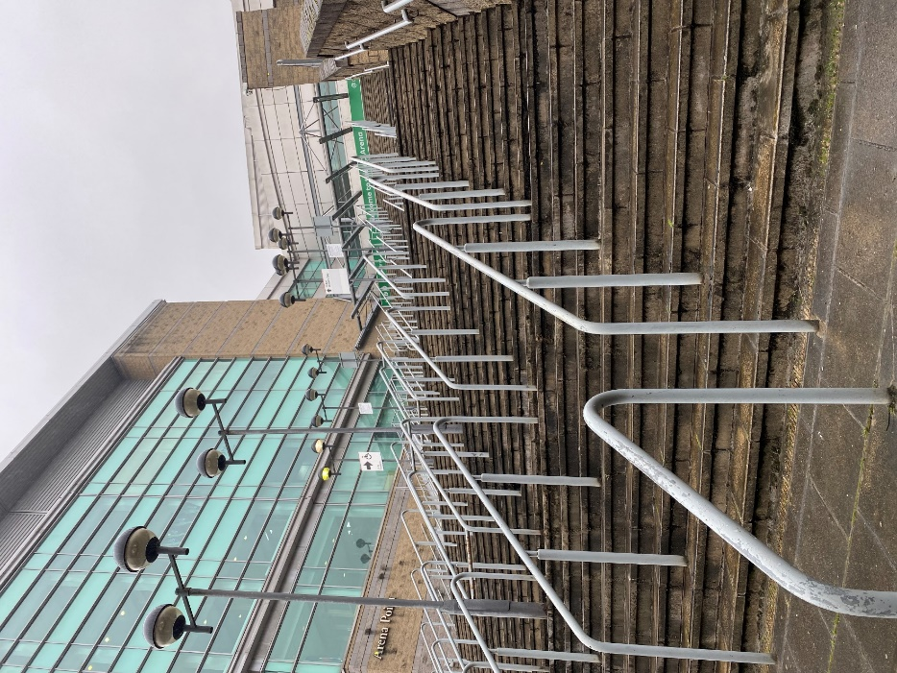
Hunts Bank
The Hunts Bank entrance is located on Hunts Bank Approach.

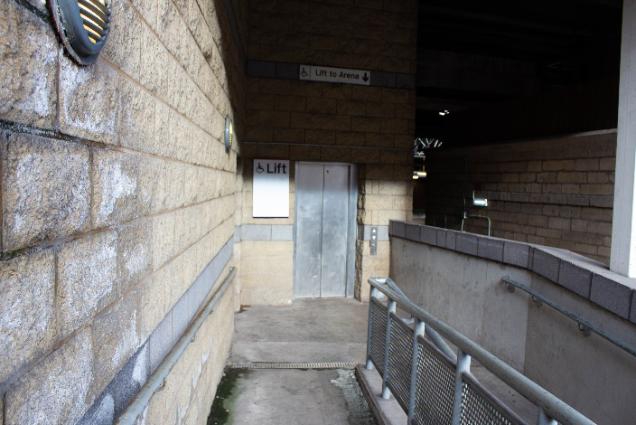
From here there is a lift to take you to the entrance.

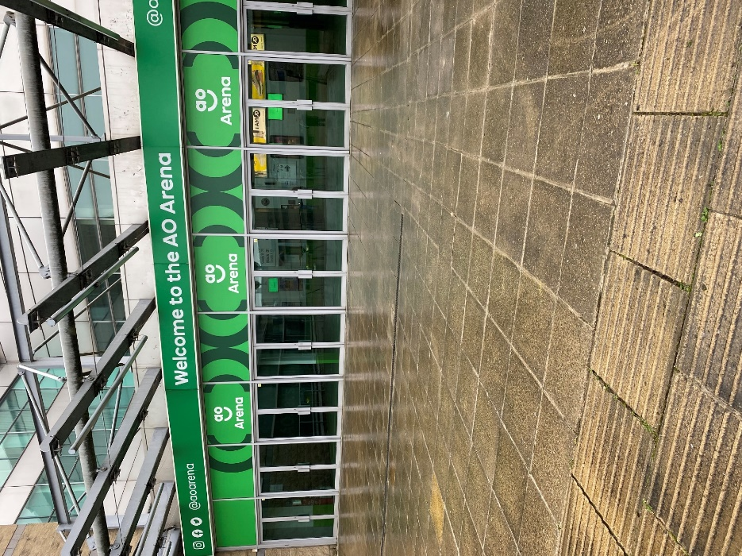

The Hunts Bank entrance is level access.

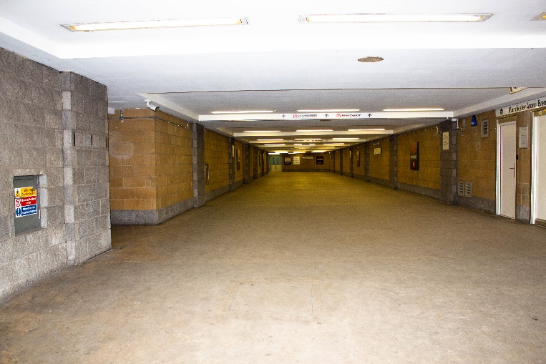
Trinity Way
There is a tunnel at Trinity Way to the entrance

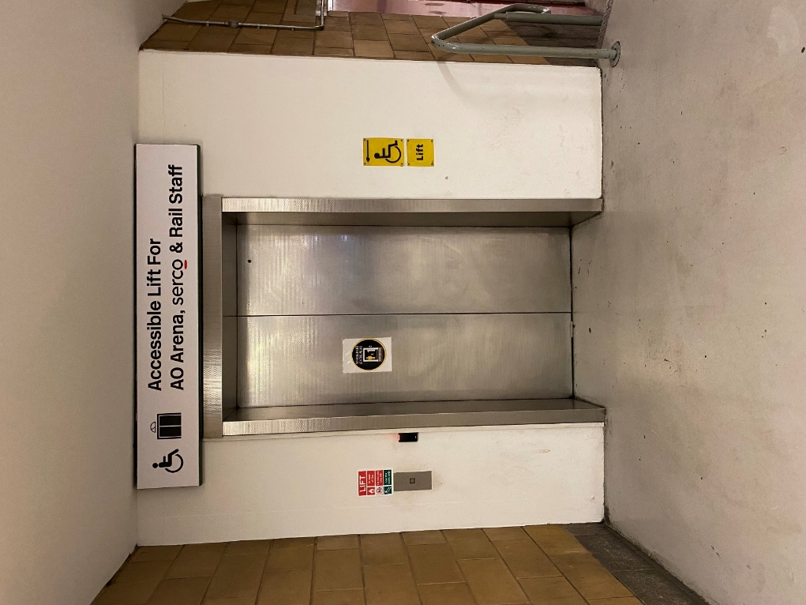
From here there is a lift to take you to the entrance.

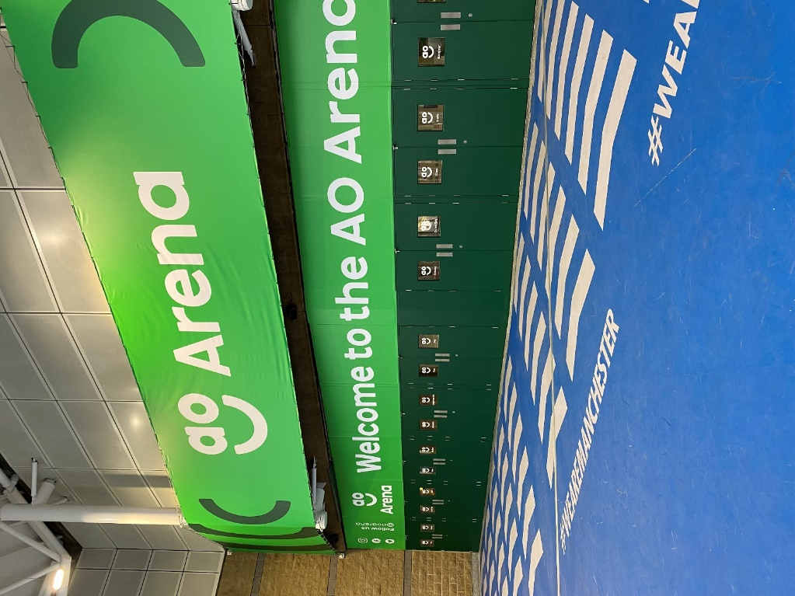

The City Rooms entrance is level access.

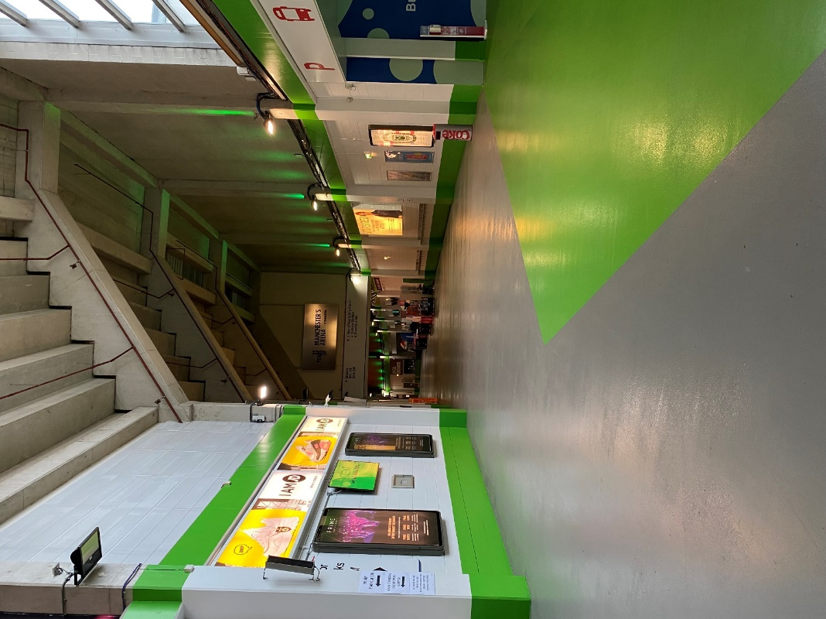
Inside the venue

The concourse is level access.

Toilets
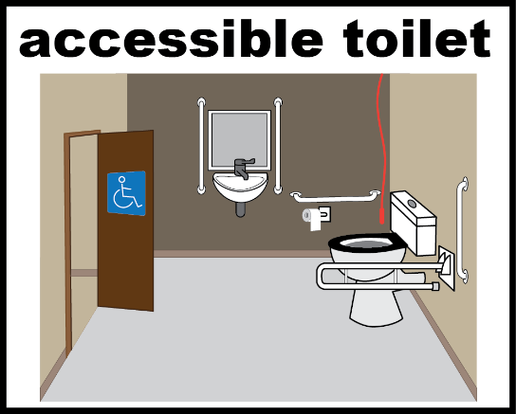
There are accessible toilets on all floors.

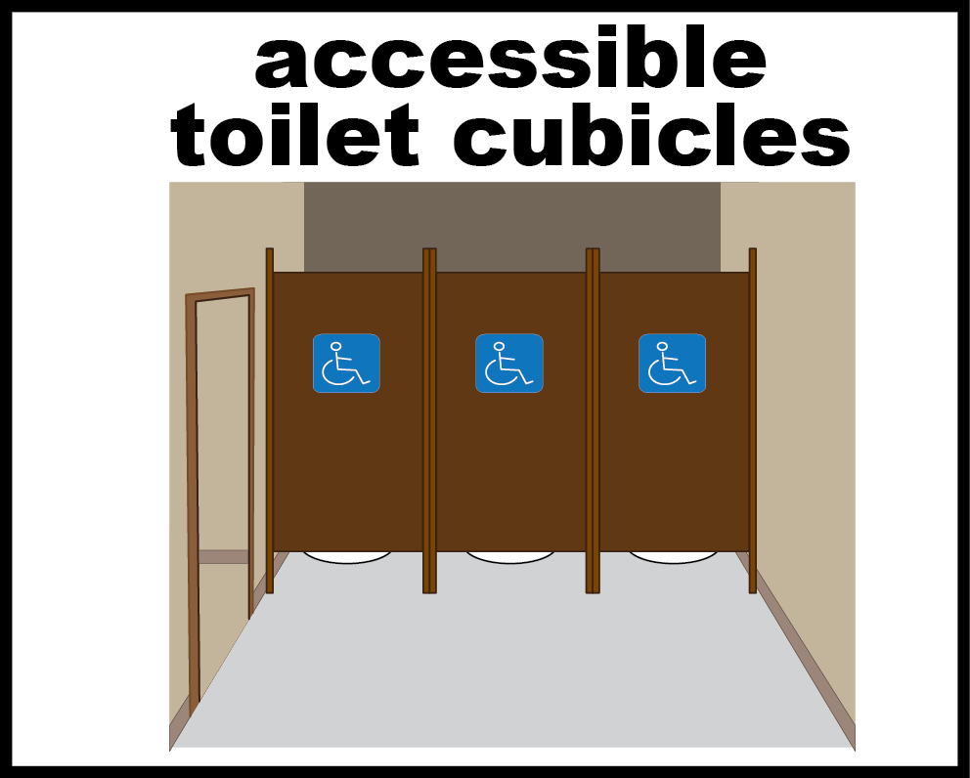
There are accessible toilets in all of our toilet blocks.

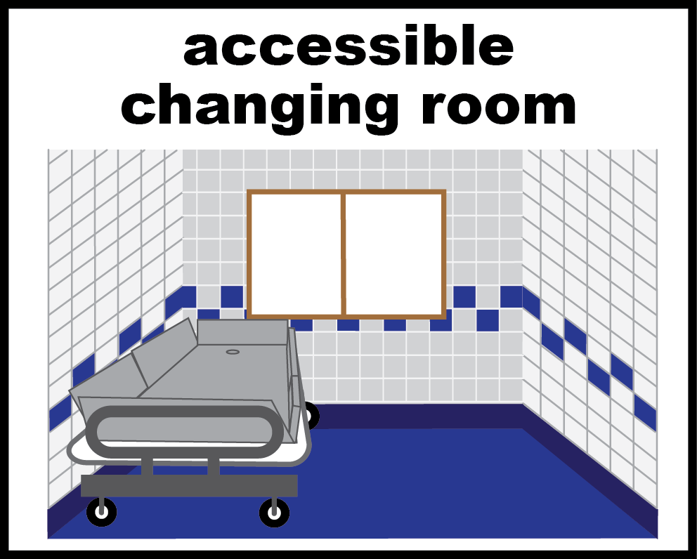
We have a changing places toilet on the lower floor. Please ask a steward to help you find it.

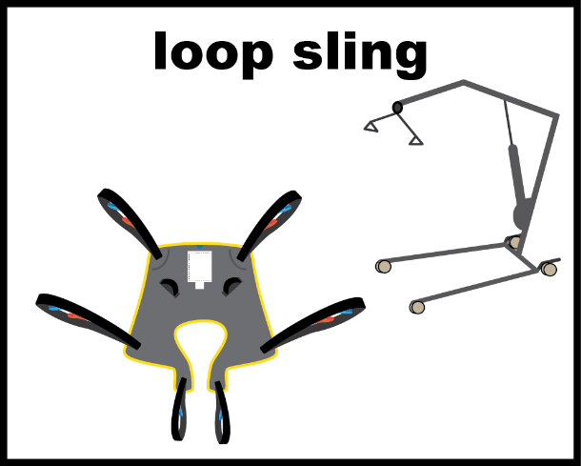
Please bring your own loop sling to use our hoist.

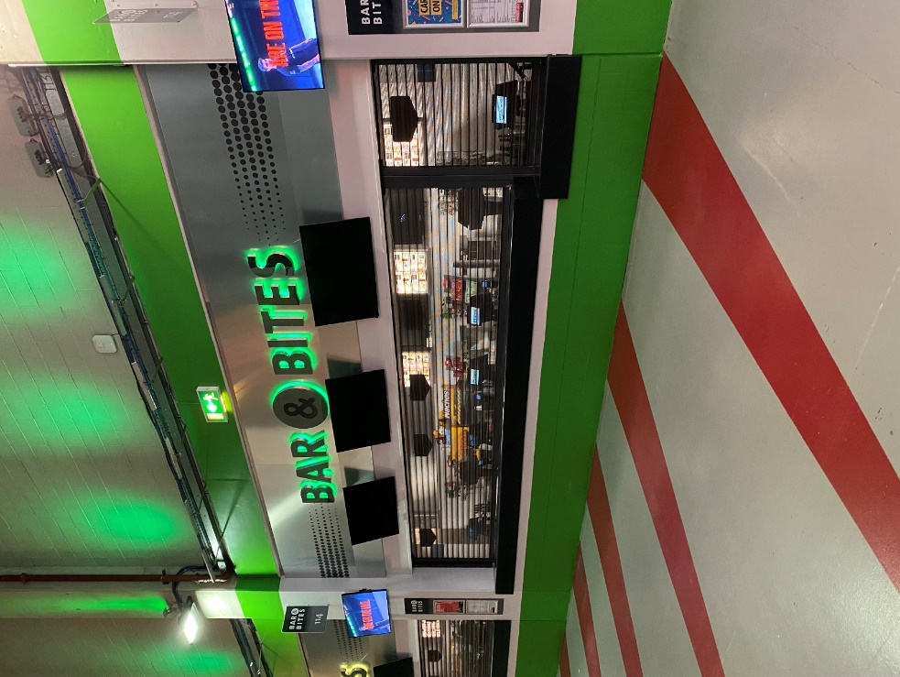
Food and Drinks
The Arena has several bars.
They have low counters at one end.
You can buy food and drinks here.


You can ask for a menu written in large print.

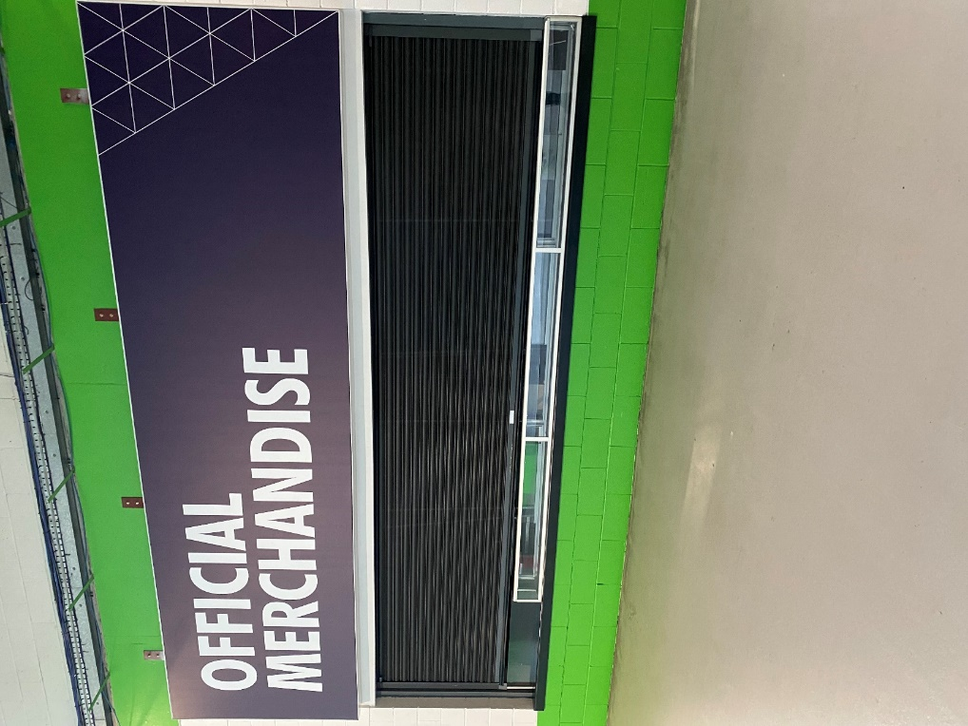
Merchandise
There are merchandise shops.
If you need help you can ask a member of staff.

Getting to your seats
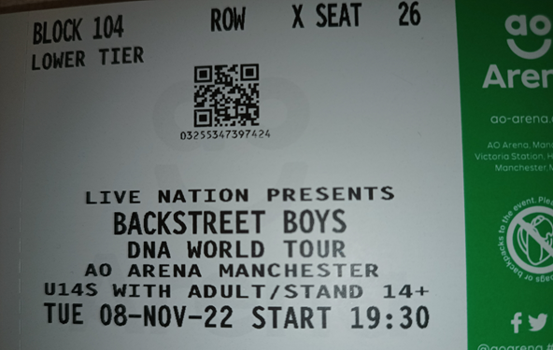
If you have a printed ticket, it will look like this. It will have a Block, Row and Seat Number.

If you have a digital ticket, it will look like this. It will have a Block, Row and Seat Number and a QR code to be scanned upon entry.
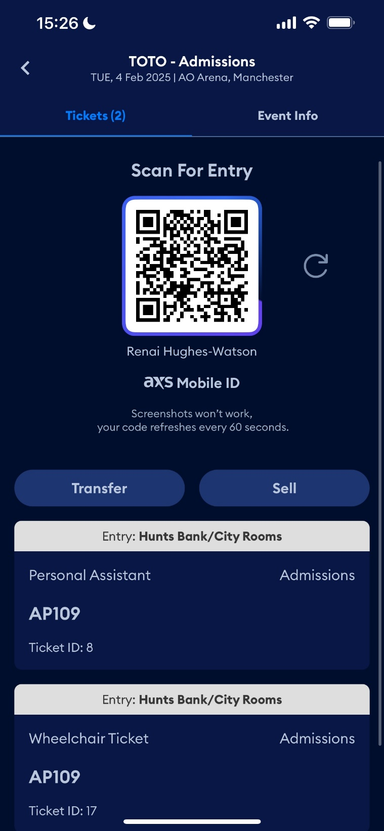

The entrances to the auditorium look like this.
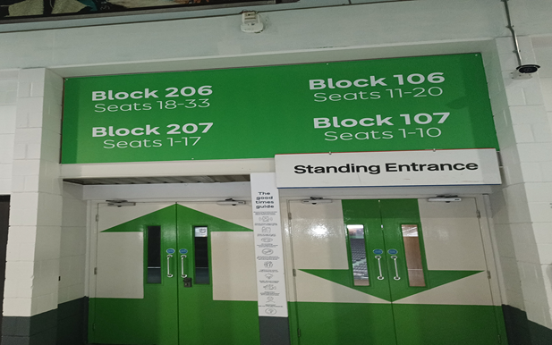
Each door has numbers on which match tickets.

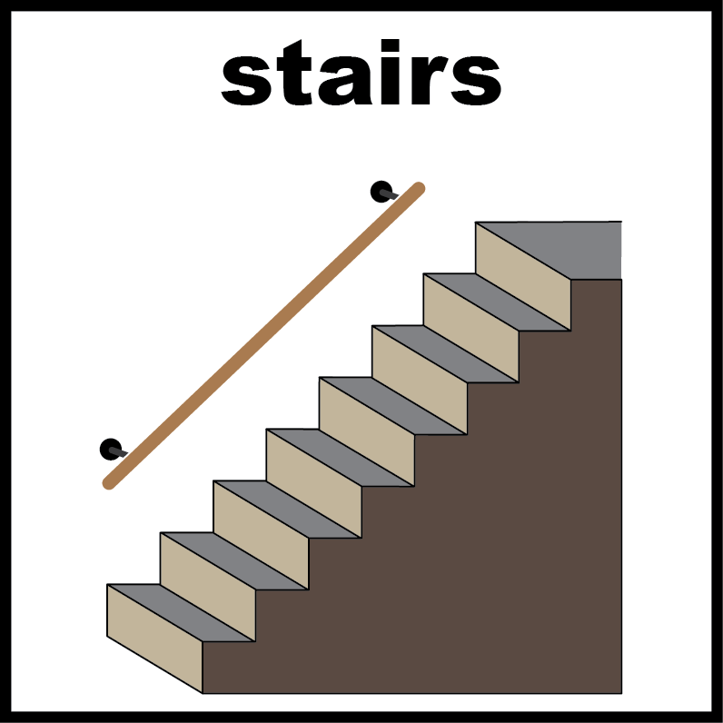
You may need to use the stairs to get to your seats.

Stewards in uniforms can help you to get to your seat.

(Please note that in the lower tier a handrail is available for the first ten steps).

Assistance in the venue
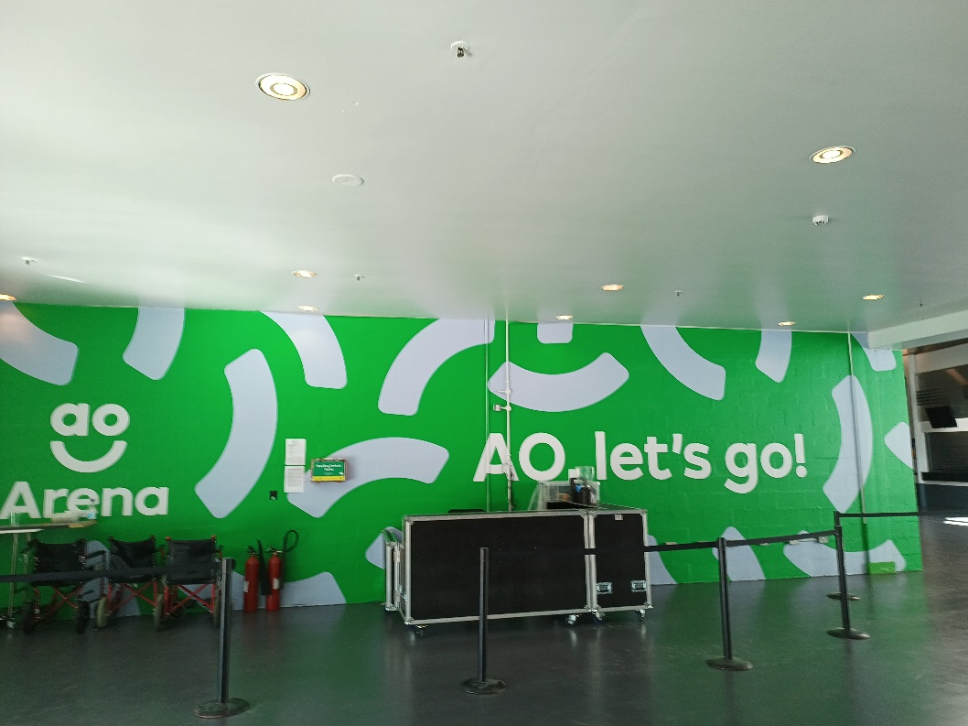
If you are worried or need help please visit our Customer Services desk at Block 101

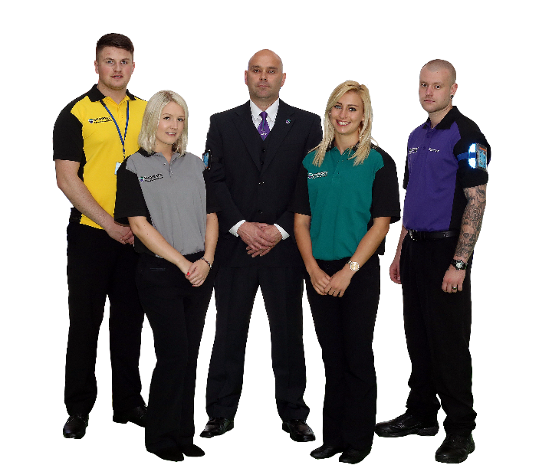
You can ask a steward for help.

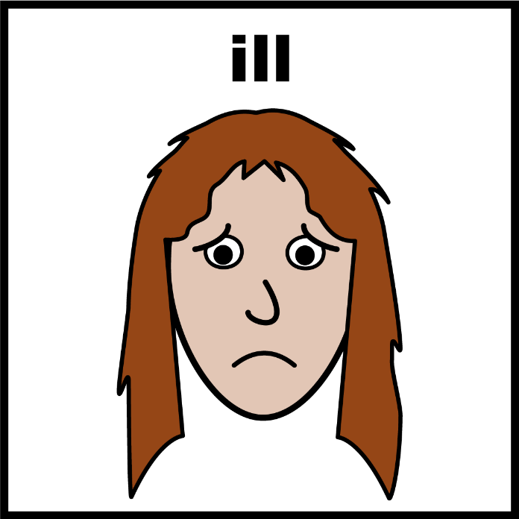
If you feel ill you can tell a steward and they will go and find someone to help you.

Assistance Dogs
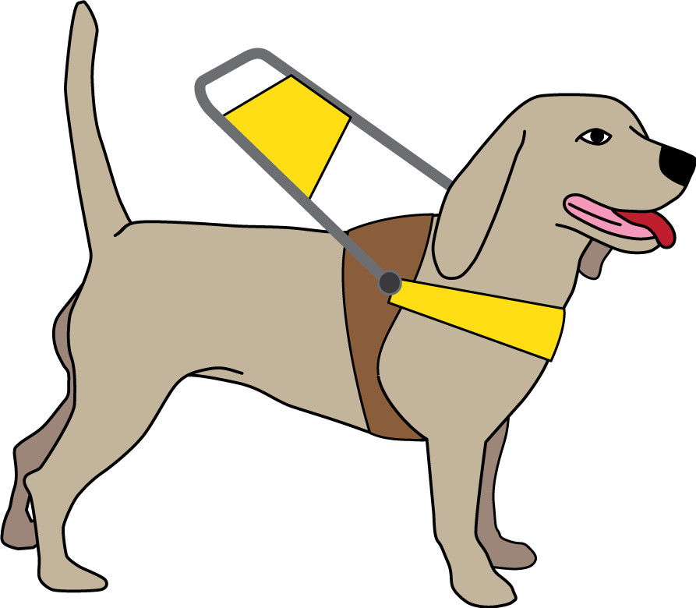
Please let us know if you are bringing your assistance dog to AO Arena.
Our staff can look after the dog whilst you are watching the show.
Call 0161 950 5229 to let us know.

Feedback and Contacting AO Arena
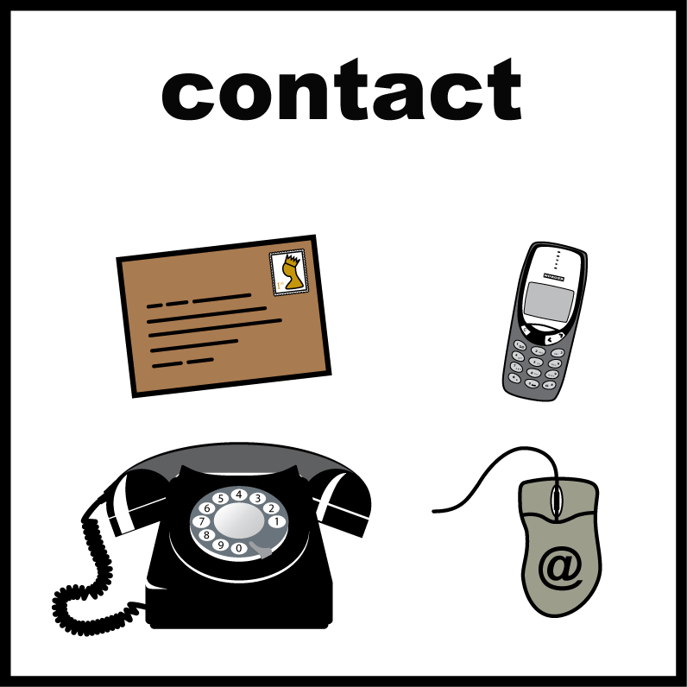
If you have any questions or if you want to tell someone how you feel about accessibility at AO Arena you can:

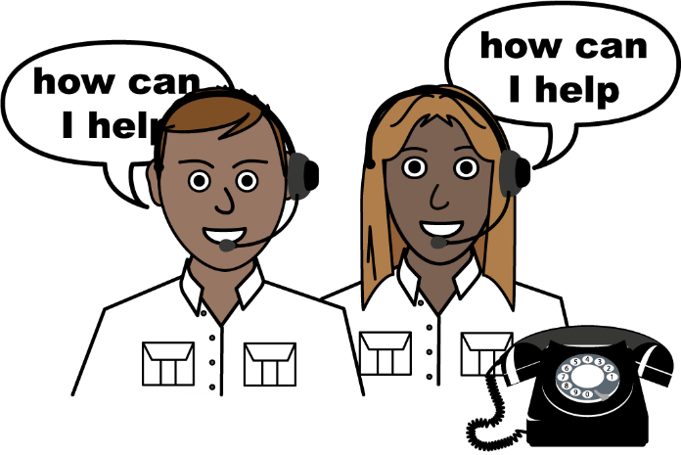
Call us on:
0161 950 5229


Email us:
contactus@ao-arena.com
feedback@ao-arena.com

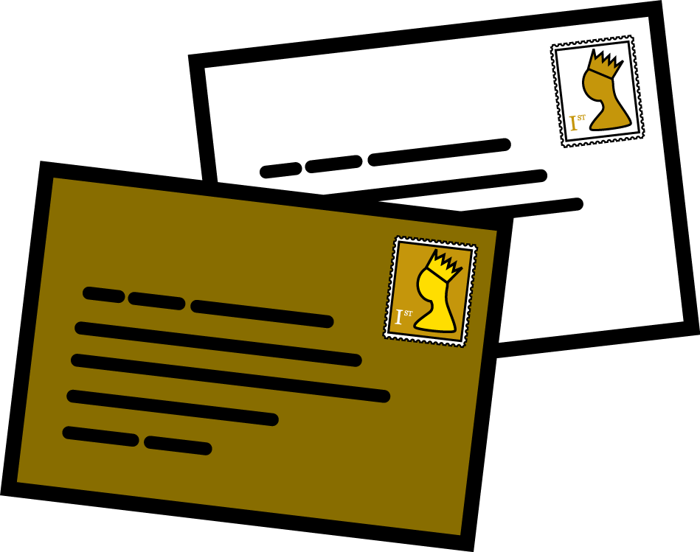
Send us a letter:
Accessibility Feedback
AO Arena
Victoria Station
Hunts Bank
Manchester
M3 1AR

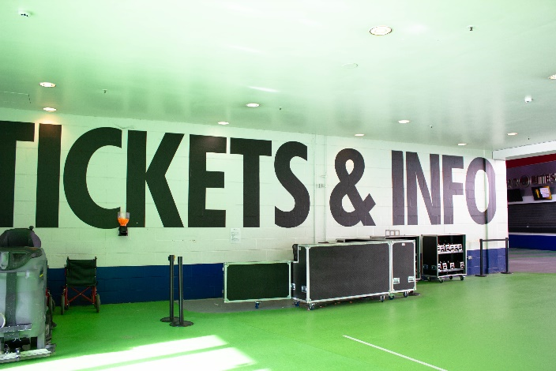
Or during your visit come to the Guest Services desk at Block 101 we would be happy to see you.

